FIA Technical Regulations – 1988

ARTICLE 1 – DEFINITIONS

- Formula One Car: An automobile designed solely for speed races on circuits of closed courses
- Automobile: A land vehicle running on at least four non-aligned complete wheels of which at least two are used for steering and at least two for propulsion
- Land Vehicle: A locomotive device propelled by its own means, moving by contantly taking real support on the earth's surface of which the propulsion and steering are under control of a driver aboard the vehicle.
- Coachwork: All entirely sprung parts of the car licked by the external air stream, except the roll-over structures and the parts definitely associated with the mechanical functioning of the engine, transmission and running gear. The airbox(es) and all radiators shall be considered part of the coachwork.
- Wheel: Flange and rim. Complete Wheel: Flange, rim and tyre
- Automobile make: In the case of Formula racing cars, an automobile make is a complete car. When the manufacturer fits an engine which it does not manufacture the car shall be considered a hybrid and the name of the engine manufacturer shall be associated with the engine manufacturer (I'd assume this part was written incorrectly and the latter part should read chassis manufacturer or constructor) Should a hybrid car win a Championship Title, Cup or Trophy this will be granted to the manufactures of the cars
- Event: An event shall consist of official practices and the race
- Weight: Is the weight of the car without the driver at all times during the event
- Racing Weight: Is the weight of the car in running order with the driver aboard and all fuel tanks full
- Cubic Capacity: Means the volume swept in the cylinder(s) of the engine by the movements of the piston(s). This volume shall be expressed in cubic centimetres. In calculating the engine capacity the number π shall be 3.1416
- Supercharging: Increasing the weight of the charge of the fuel-air mixture in the combustion chamber (over the weight induced by normal atmospheric pressure, ram effect and dynamic effects in the intakes and/or exhaust system) by any means whatsoever. The injection of fuel under pressure is not considered to be supercharging
- Sprung Suspension: All road wheels/axles must be suspended from the chassis/body unit by springing mediums (ie axles or wheels must not be connected directly to the chassis body unit) The springing medium must not be comprised of bolts located through flexible bushes or flexible mountings.
There must be independent movement of the axles/wheels uprights/stub axles giving suspension travel from 'bump' to 'droop' in excess of he flexibility of the mounting location attachments.

ARTICLE 2 – REGULATIONS

- The following regulations governing the construction of Formula 1 cars listed below are issued by the FIA.
- Each year in October the FIA will publish all changes made to these regulations. All such changes will take effect on the third 1st January following their publication unless otherwise agreed between the FIA and all Formula One recognised constructors, in which case the change will take effect on the date agreed.
- If an automobile is is deemed to be dangerous, it may be excluded by the Stewards of the Meeting
- Automobiles must comply with these regulations in their entirety at all times during an event
- All measurements must be made while the car is stationary on a flat horizontal metalled surface, or as provided in Article 10.1 of the standard regulations
- It is the duty of each competitor to satisfy the Scrutineers and the Stewards of the Meeting that his automobile complies with these regulations in their entirety at all times during the event.

ARTICLE 3 – COACHWORK AND DIMENSIONS

- The overall width of the car including complete wheels shall not exceed 215cm with the steered wheels in the straight ahead position.
- The coachwork ahead of the front wheels may be to extended to an overall maximum width of 150cm. Nevertheless, any part of the coachwork ahead of the front wheels exceeding an overall width of 110cm shall not extend above the height of the front wheel rims with the driver aboard seated normally and irrespective of the fuel load.
- The overall maximum width of the coachwork behind the rearmost edge of te complete front wheels and front of the centreline of the rear wheels shall not exceed 140cm. The crushable structure is included in this width. Between the rear edge of the complete front wheels and the front edge of the complete rear wheel all sprung parts of the car visible from directly beneath the car must lie on one plane within a tolerance of +/- 5mm.
All these parts must produce a uniform, solid, hard, rigid (no degree of freedom in relation to the body/chassis unit) impervious surface, under all circumstances
The periphery of the surface formed by these parts may be curved upwards with a maximum radius of 5cm
No parts of the bodywork in front of the centre-line of the rear wheels and extending above the the height of the rear complete wheels may project beyond 50cms each side of the longitudinal axis of the car.
- Coachwork behind the centreline of the rear wheels shall not exceed 100cm in width
- Except in the case of front wheel drive when the measurement will be taken from the centreline of the rearmost sustancial load carrying wheels no part of the car shall be more than 60cm behind the centreline of the rear most driving wheels. No part of the car shall be more than 120cm in front of the centre-line of the foremost fronts wheels. The centre-line of any wheel shall be deemed to be half way between two straight edges perpendicular to the surface on which the car is standing, placed against opposite side of the complete wheel at the centre f the tyre tread.

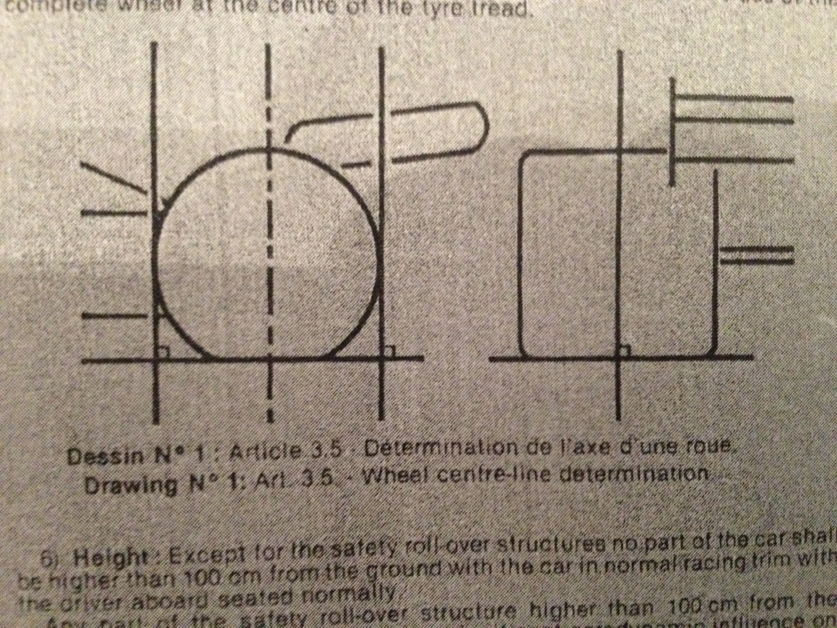
- Height: Except for te safety roll-over structures no part of the car shall be higher than 100cm from the ground with the car in normal racing trim with the driver aboard seated normally
Any part of the safety roll-over structure higher than 100cm from the ground must no be shaped to have a significant aerodynamic influence on the performance of the car
- Any specific part of the car influencing it's aerodynamic performance
- must comply with the rules relating to coachwork
- must be rigidly secured to the entirely sprung part of the car
Any device or construction that is designed to bridge the gap between the sprung [art of the car and the ground is prohibited under all circumstances
No part having aerodynamic influence and no part of the coachwork may under any circumstances be located below the geometrical plane generated by the plane surface provided for article 3.5

ARTICLE 4 – WEIGHT

- The weight of the cr must be not less than:
- 500kg for the cars with engine without supercharging or
- 540kg for the cars with supercharged engine
- Ballast can be used provided it is secured in such a way that tools are required for it's removal. It must be possible to fix seals if deemed necessary by the scrutineers
- The adding to the car during the race of any liquid or other material whatsoever or the replacement during the race of any part of the car with another materially heavier is forbidden.

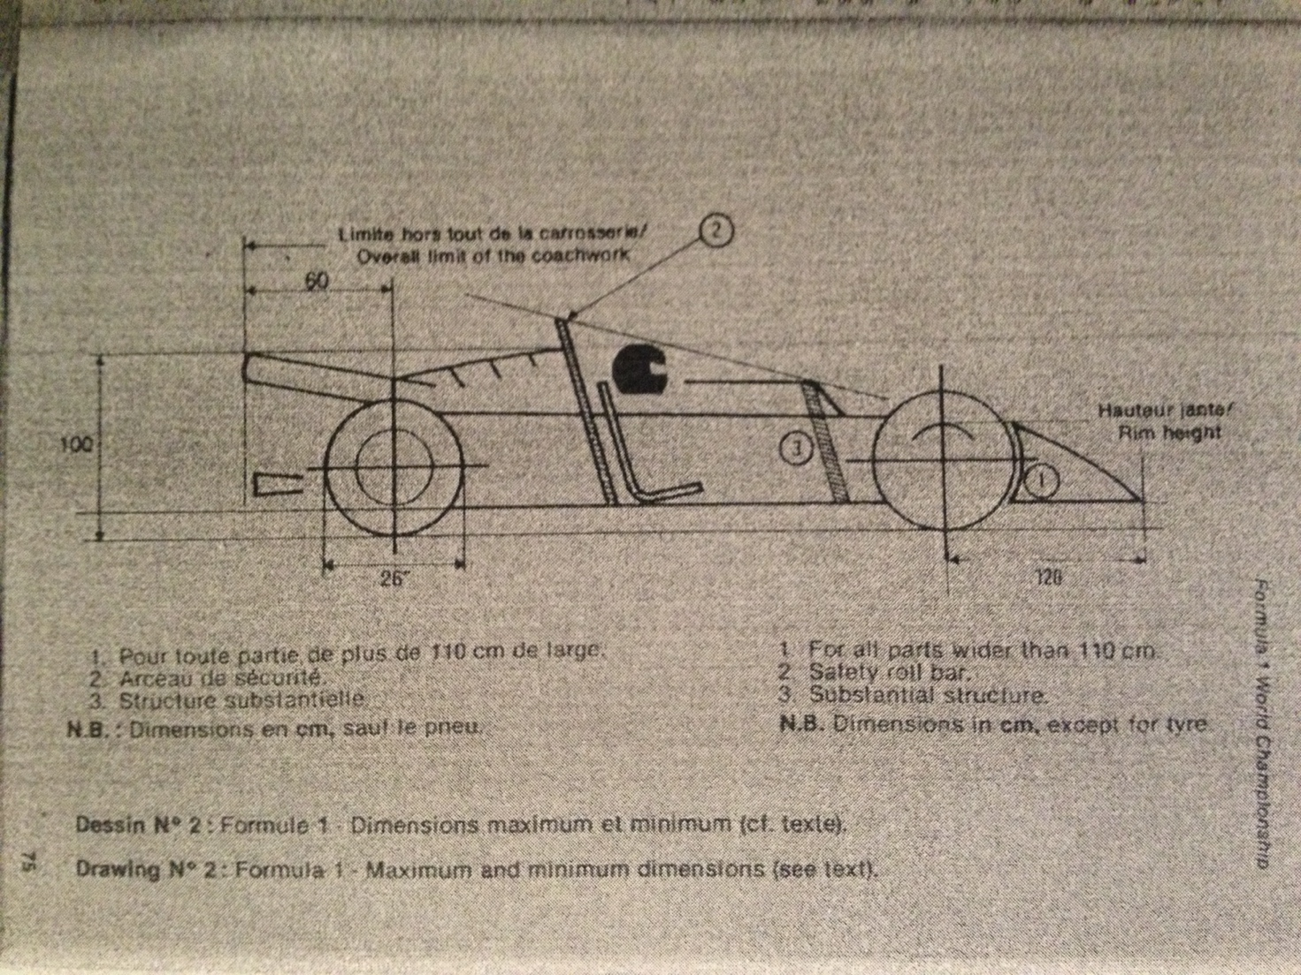
ARTICLE 5 – ENGINE

- 4 stroke engines with reciprocating pistons
- maximum engine cubic capacity without superhcarging 3500cc
- maximum engine cubic capcity with supercharging 14500cc
the only authorised mean of supercharging shall be the one or more turbo chargers exclusively driven by the exhaust gases of the engine, which sall not be mounted in series. each turbocharger shall consist of a single compression stage of the intake air and a single expansion stage of the exhaust gases
number of cylinders: maximum 12
the normal section of each cylinder must be circular
the wankel, diesel, 2-stroke and turbines are forbidden
- Manifold pressure control
A) All cars with supercharged engine must be equipped with FISA manifold pressure relief valve(s) “(The Valve(s)”) at all times during official practices and the race, in compliance with the following provision and procedure in order that the manifold pressure shall not exceed the figure referred to in paragraph B) hereunder
FISA shall publish at least three months prior to the first event of each FIA F1 World Championship the characteristics of the approved Valve, the name and address of the manufacturer and the scheme for it's installation.
B) The allowable manifold pressure shall be limited by the approved Valve set to a maximum pressure of 2.5 BAR absolute at standard temperature and pressure (STP)
C) A hole complying with the installation scheme referred to above is required for mounting each Valve. Such hole shall have no reduction in size into the main manifold. The Valve(s) must be mounted directly in an unobstructed part of the principal section of the intake manifold and the mounting surface must be flush with the manifold.
The Valve(s) shall be mounted as follows:
(I) Engines with a single intake manifold at least one Valve shall be p[laced on the the manifold
(ii) Engines with two or more intake manifolds (even if connected between them) one Valve shall be placed in each manifold
Any insulator and/or gasket which is used must not exceed 5mm in thickness and must comply with the provisions of Art 5.2 C)
All installations must be approved by the FISA delegate responsible for scrutineering
In all cases the Valve(s) must not be mounted on any inlet or connecting pipe and must be easily and rapidly accessible for removal, sealing and inspection by the scrutineers. Any scoop or other device that could direct airflow on the Valve(s) shall be forbidden
- Temperature of the charge
- Any device, system, procedure, construction or design the purpose and/or effect of which is any decrease whatsoever of the temperature of the intake and/or of the charge (air and/or fuel) of the engine is forbidden with the sole exception of heat exchange(s) whose only function is to directly exchange heat between the charge and ambient air (“air to air intercoolers”) Such heat exchanger(s) shall not be driven by energy from any other source and shall not have any moving part
- Internal and/or external spraying or injection of water or any substance or matter whatsoever is forbidden (other than fuel for the normal purpose of combustion in the engine)

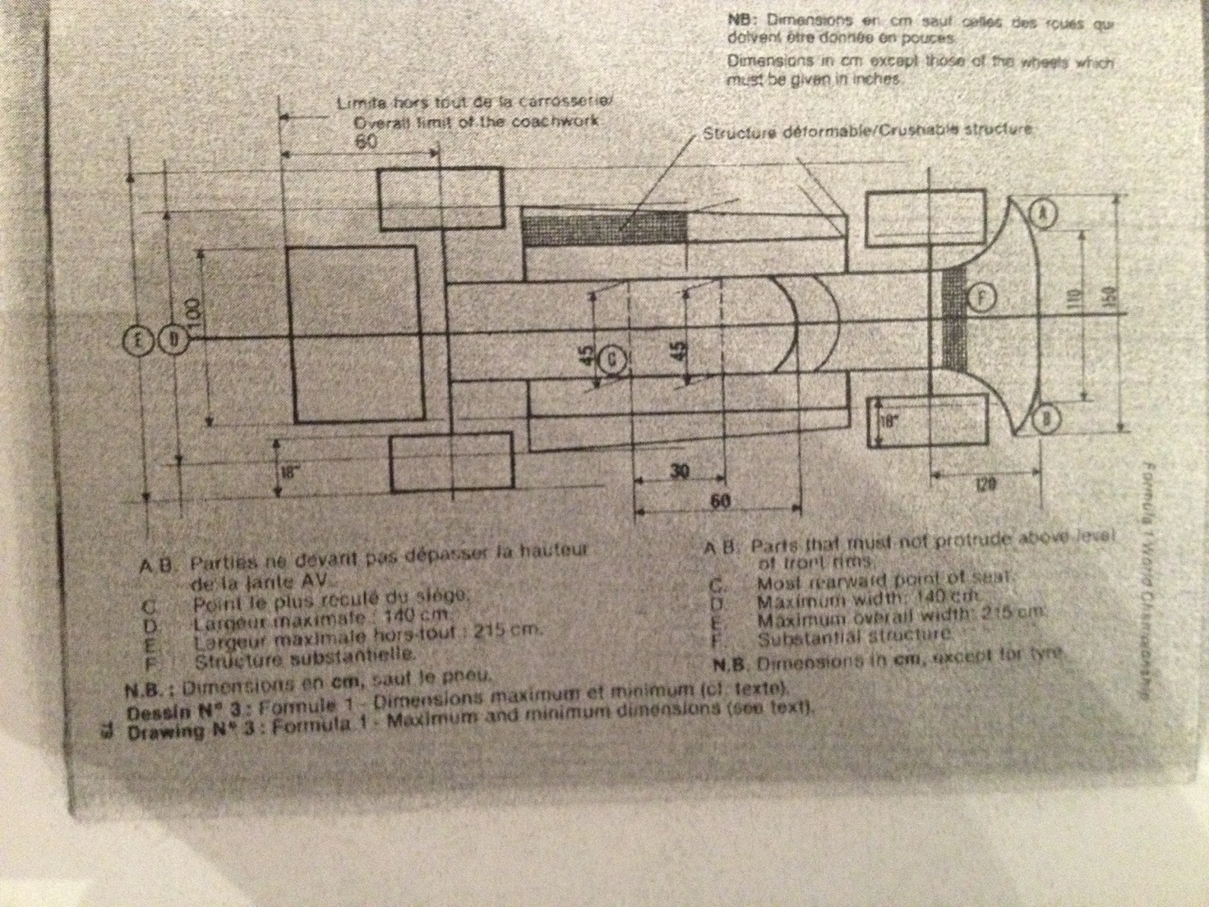
ARTICLE 6 – PIPING AND PETROL TANKS, CABLES AND ELECTRICAL EQUIPMENT

- The total fuel storage capacity of the automobile shall not exceed 150 litres for the cars with supercharged engineereNo fuel storage capacity restriction apply to cars with engine without supercharging
This definition refers to all of the volumes of the fuel system(s) (including any part of the automobile used as such) capable of containing, even temporarily, any fuel including, but not limited to the main tank(s) the auxiliary tank(s), the catch tank(s), the tank filler(s), the fuel radiator(s), the fuel pump(s), the fuel injection system(s) etc
Any device, system, procedure, construction,design etc the purpose and/or effect of which is any increase whatsoever, even temporarily, of the total fuel storage capacity beyond the maximum provided for in Art 6.I, is forbidden including but not limited to:
- fuelling the car other than by gravity from a maximum head of 2 meters
- fuel tank(s) or other elements of the fuel system(s) or any other part of the automobile capable of deforming and/or expanding and /or reducing the volume so as to achieve even temporarily, a total fuel storage exceeding the maximum allowed by Art 6.I
Any storage of fuel on board of the car at a temperature more than ten centigrade below the ambient temperature is forbidden
The use of any specific device (whether on-board or otherwise) to decrease the temperature of the fuel below the ambient temperature is forbidden
Each competitor undertakes to fullu co-operate with the Scrutineers, I particular should any dismantling of the automobile be required during scruitineering.
- All fuel tanks must be situated within the main structure of the car. The stocking of petrol at more than 40cm from the longitudinal axis of the car and in the longitudinal box members, defined by article 13.7-F, is forbidden.
- All fuel tanks must be rubber bladders conforming to or exceeding specifications of FTA/Spec/FT3.
- All rubber bladders must be made by manufacturers recognised by the FIA. In order to obtain the FIA's agreement a manufacturer must prove the compliance of its product with the specifications approved by the FIA. These manufacturers must undertake to deliver ther customers exclusively tanks complying with the norms appoved.
- All rubber bladders shall have a printed code indicating the name of the manufactuers, the specifications to which the tank has been manufacturered and the date of manufacturer.
- No rubber bladders shall be used more than 5 years after the date of manufacturer.
- All fuel fittings (including air vents, inlets, outlets, tank fillers, inter tank connectors and access openings) must be metal fittings bonded on to the fduel tank
- All connections between any fuel tank and the chassis (including tanlk fillers, air vents, access openings, inlets and outlets) must be frangible. By frangible is meant that should be the fuel tank move relative to the chassis during an accident, the connection between the fuel tank and the chassis will fail at a load which is less than 50% of the load required to pull the bonded metal fitting out of the tank.
- All fuel lines between any fuel tank and the engine must have a self-sealing breakaway valve. This valve must separate at less than 50% of the load required to fail the fuel line fitting out of the fuel tank.
- Cables, lines and electrical equipment: Except if the cables, lines and electrical equipment are in compliance with the requirements of the aircraft industry as regards their location, material and connections, they must be placed or fitted in such a way that any leakage cannot result in:
- accumulation in the cockpit
- contact between liquid and any electrical line or equipment
Should the cables, lines or electrical equipment pass through or be fitted in the cockpit, they must be fully enclosed in a cover of a liquid-tight and fire resistant material.
- All fuel lines external to the cockpit, with the exception of line permanently mounted on the engine, must be capable of withstanding a pressure of 70kg/cm² (1000psi) and a temperature of 260ºC (500ºF)
- Crushable Structures: The entire fuel tank area of the car in direct contact with the open air stream must incorporate a crushable structure which is an integral part of the car conforming to the specifications hereafter.
This area includes the complete external area of body/monocoque construction irrespective of such added items as water radiators, inlet ducts, windscreens etc.
a) The crushable structure should be a sandwich construction based on fire-resistant core of a minimum crushing strengh of 25lb/square inch (18 N/cm²). It shall be permitted to pass water pipes through this core, but not fuel, oil or electrical lines.
The sandwich construction must include two sheets of 1.5mm thickness one of which shall be aluminium alloy sheet having a tensile strength of 14 tons/square inch (225 N/mm²) and minimum elongation of 5 per cent. Alternatively, the sandwich construction must include two sheets of 1.5mm thickness having a tensile strength of 14 tons/square inch (225 N/mm²)
b) The minimum thickness of the sandwich construction must be 1cm
- Tank Fillers and caps: The tank fillers and their caps shall not protrude beyond the coachwork. The filler shall have a sufficient diameter to allow for the air exhausted at the time of quick refuelling (in particular those done under pressure). Any breather pipe connecting the tank with the atmosphere shall be designed to avoid liquid leakage when the car is running and its outlet must not be less than 25 an to the rear of the cockpit. All filler caps must be designed to ensure an efficient locking action which reduces the risks of an accidental-opening following a crash impact or incomplete locking after fueling.
- Refuelling during the race: Refuelling during the race is forbidden. The distance of all races (from the green light to the finish) will be such that, after the addition of the formation lap referred to in article 13 c 3 d of the Standard Regulations, it will not exceed 320km nor be less than 300km, save only that should two hours elapse before the scheduled race distance is completed, the leader will be shown the chequered flag at the end of the lap in which the period of two hours shall end.

ARTICLE 7 – OIL

- All oil storage tanks sitiuated outside the main structure of the car must be surrounded by 1cm thick crushable structure
No part of the car containing oil may be situated aft of the gearbox or final drive casing on any rear wheel driven car. In the case of front wheel drive, no part containing oil may be situated behind the complete rear wheels.
- All oil lines external to the cockpit, with the exception of lines permanently mounted on the engine, must be capable of withstanding a pressure of 70 kg/cm² (1000psi) and a temperature of 260º (500ºF)
- Oil Catch Tank: When a car's lubrication system includes an open type sump breather, this breather must vent into a catch tank of at least 3 litres capacity.
- No part of the car containing oil may be more than 70cm from the longitudinal centre-line of the car
- No oil replenishment is allowed during a race

ARTICLE 8 – STARTING

A supplementary device temporarily connected to the car may be used to start the engine both on the grid and in the pits

ARTICLE 9 – TRANSMISSION TO THE WHEELS

- Four wheel drive cars are prohibited
- All automobiles must have a reverse gear which must be in working order when the car starts the event and which can be operated by the driver when seated normally in the car.

ARTICLE 10 – BRAKES

- All cars must have a brake system which has at least two separate circuits operated by the same pedal. This system must be designed so that if leakage or failure occurs in one circuit, the pedal shall still operate the brakes on at least two wheels
- Air ducts for the purpose of of cooling the front brakes shall not protrude beyond:
- a plane parallel to the ground situated at a distance of 140mm above the horizontal centre line of the wheel
-a plane parallel to the ground situated at a distance of 140mm below the horizontal centre line of the wheel
- a vertical plane parallel to the inner face of the front rim and siplaced from it by 120mm toward the centre-line of the car
Furthermore such ducts, when viewed from the side must not protrude beyond the periphery of the tyre in a forward sense of the rim or a rearward sense.

ARTICLE 11 – WHEELS & TYRES

- Wheels shall be external to the coachwork with the car viewed in plan with the rear aerodynamic device removed
- The maximum complete wheel width is 18 inches and its maximum diameter is 26 inches. These measurements will be taken horizontally at axle height
- The number of wheels is fixed at four.

ARTICLE 12 – COCKPIT

- The opening giving access to the cockpit must have the following minimum dimensions:
- length; 60cm
- width; 45cm maintained over 30cm from the most rearward point of the backrest towards the front.
The driver must be able to enter and get out of his seat without it being necessary to open a door or move away any part of the car. Sitting at his steering wheel the driver must be facing forward.
The cockpit must be so concieved that the maximum time necessary for the driver to get out does not exceed 5 seconds with the steering wheel in place
- All cars must have at least two mirrors mounted so that the driver has visibility to the rear on both sides of the car
The scrutineers must be satisfied by a practical demonstration that the driver when normally seated in his driving position, can clearly define following vehicles
- Safety Belts: The wearing of two shoulder straps, one abdominal strap and two straps between the legs is mandatory. These straps must be securely fixed to the car.

ARTICLE 13 – SAFETY

- Fire extinguishers:
a) Extinguishing product: BDF (CF₂CIBr) – BTM (Cbr F₂) – TDE (C₂Br₂F₄)
b) Minimum Capacity:
Drivers compartment: 5KG
Engine compartment: 2.5KG
c) Location – Mounting method: The extinguisher bottle must be adequately protected and the bottle for the drivers compartment must be mounted within the main structure of the car. In all cases the bottle must be able to withstand a 25g acceleration.
d) Discharge time:
Engine compartment: 300+/- 5 seconds for BCF and TDE: 60+/- seconds for BTM
Both bottles should be released simultaneously
e: Drive system: Any triggering system having its own source of energy is permitted provided it is possible to operate all extinguishers in case the main electric circuits of the car fail the driver must be able to trigger all extinguishers when seated normally in the car with his safety belts fastened and steering wheel in place
f: Checking of the bottles: The following weights shall be indicated on each bottle: weight of the empty bottle, weight of the extinguishing agent, total charged weight
g: Operation: The system must work in any position, even when the car is inverted
- Life support system: A life support system consisting of a medical air bottle and flame resistant pipe for connection to the drivers helmet shall be fitted to the car and available for connection to the drivers helmet at all times
- Master-Switch: The driver seated normally with his safety belt fastened and the steering wheel in place, must be able to cut off all electrical circuits by means of a spark proof breaker. There must also be a clearly indicated external handle which rescue personnel can operate at a distance by a hook. This handle must be located near the base of the main roll over bar structure and be marked with a symbol showing a red spark in white edged blue triangle with a base of at least 10cm.
- All cars must have a red warning light of at least 25 watts in working order at the start of the race which faces rearward, is clearly visible from the rear, is mounted not more than 10cm from the car centre line, has a minimum surface area of 20cm², a maximum surface of 40cm², can be switched on by the driver when seated normally in the car.
- Chromium plating of steel suspension members of over 45 tons/inch² (725mm N/mm²) tensile strength is forbidden.
- The use of magnesium sheet less than 3mm thick is forbidden.
- Safety structures:
a) The basic purpose of safety structures is to protect the driver. This purpose is the primary design consideration
b) All cars must have at least two roll-over structures:
i) The first roll-over structure must be in front of the steering wheel, not more than 25cm forward of the steering wheel rim and at least as high as the top of the steering wheel rim.
ii) The second roll-over structure must be not less than 50cm behind the first and high enough for a line extended from the top of the first structure to the top of the second to pass over the drivers helmet when he is seated normally in the car with his helmet on and seat belts fastened.
If the second structure is not located the driver there must be a structure behind him which is high enough so that a line extended from its top to the top of the structure in front of him will pass over the top of his helmet when he is seated normally with his helmet on and seat belts fastened.
c) All safety structures required by paragraph b must when attached to the car, be capable of withstanding three loads applied simultaneously to the top of the structure which are 1.5w laterally, 5.5w longitudinally and 7.5w vertically, w being the racing weight of the car.
d) The design concept of the safety structure required by paragraph b shall be free. Forward facing stays which restrict the dimensions of the cockpit access required by Article 12 paragraph 1, are permitted provided the driver can exit the cockpit in the time required in that paragraph
e) All cars must have a structure immediately behind the drivers seat which is wider than and extends above his shoulders when his is seated normally in the car with his seat belts fastened. This structure must be capable of withstanding a substantial lateral load of 1.5w applied to its top, w being the racing weight of the car
f: Survival Cell
1) The chassis structure shall include two continuous box members, one on each side of the driver
The chassis must incorporate at least one transversal hoop at the main roll bar level, one in front of the soles of his feet with the driver seated normally and with his feet on the pedals and the pedals in the inoperative position. The foremost 40cms of each box member need not be an integral part of the chassis but must be solidly fixed to it.
The soles of the feet of the driver, seated in the normal driving position and with his feet on the pedals and the pedals in the inoperative position shall not be situated to the fore of the vertical plane passing through the centre line of the front wheels. Should the car not be fitted with pedals, the drivers feet at the maximum forward extension shall not be situated to the fore of the above referred vertical plane.
N.B: The above provisions concerning the position of the drivers feet relation to the vertical plane passing through the centre line of the front wheels shall not apply until 31.12.1988 to those cars with supercharged engine, for which the competitor can prove that the whole chassis has the same design and specifications as the one used by him during the 1987 World Championship.
3) Throughout it's length, the structural material in the cross section of each box member shall have a minimum area of 10cm², a minimum tensile strength of31kg/mm² and a minimum panel thickness of 1mm on unstabilised skins or 5cm² area and 0.5mm thickness on stabilised skins.
4) Throughout it's length from behind the driver to the soles of his feet each box must have a minimum cross sectional area of 150cm². Forward of this, the boxes may taper to a minimum cross section of 100cm² and minimal structural material cross section of 5cm² for unstabilised skins or 2.5cm² with stabilised skins.
5) All holes and cutouts in the boxes shall be strongly reinforced and all material sections through these holes shall still comply with minimum area requirement of 10cm2 for unstabilised skins and 5cm² for stabilised skins
6) The internal cross sectional area of the cockpit from the soles of the drivers feet to behind his seat shall nowhere be less than 700cm² and the minimum width must be 25cm over the whole length of the cockpit.
7) The minimum height of the box between the front and rear roll-over bar structures shall be not less than 30cm
8) Furthermore, at least that part of the box members, forward of a transversal section 20cm to the rear of the soles of the drivers feet, in static position, shall be subjected to an impact test against a solid vertical barrier placed at right angles to the longitudinal axis of the car. If such a part of the box members is tested independently of the rest of the chassis structure it must be attached to the trolley in such a way as to not increase its impact resistance. For the purpose of the test the total weight of the trolley and test structure or complete car shall be 780kg and the velocity of impact 10 metres per second.
The resistance of the box member must be such that during the impact an average deceleration of not more than 25g is recorded, and the final deformation is contained within the zone ahead of the soles of the drivers feet.
In addition to the frontal impact test, the chassis shall be subjected to a lateral load test:
- in the cockpit area, and
- in the fuel tank area,
A pad of 10cm length and 30xm height conforming to the shape of the chassis shall be placed against both sides of the outermost structure of the chassis, with the lower edge of the pads at the lowest part of the chassis. A plane through the vertical centre line of the pads shall pass through the centre of the seat belt lap strap fixing. A constant tranverse horizontal load of 2000kg shall be applied to the pads at their centre of area through a pinjointed junction. After 1 / 2 minute of aqpplication the inside structure of the chassis across the defined plane must not reduce in dimension by more than 2cm under the applied load.
The same load conditions shall be applied across the chassis structure in the fuel tank area at a vertical place passing through the centre of area the fuel tank in side elevation
Under these load conditions there shall be no structural failure of the inner surfaces of the chassis structure.
Such tests must be carried out under the supervision of a FISA technical delegate in recognised testing laboratories in either Italy, Great Britain, USA, Germany or France approved by FISA.
A dossier defining the structure, test method and results shall be submitted to FISA before the use in a F1 event of the relevant model of car.
Any significant modification introduced to the frontal and/or lateral part of the chassis structure shall require it undergo further test.

ARTICLE 14 – FUEL

- The only fuel permitted is petrol having the following characteristics:
- a maximum of 102 RON, the measurement being made according to the standard ASTM D 2699, the fuel being accepted or rejected according to ASTM D 3244 with a confidence limit of 95% and
- a maximum of 2% oxygen and 1% nitrogen by weight, the remainder of the fuel consisting exclusively of hydrocarbons and not containing any alcohols, nitrocompounds or other power boosting additives.
For all events taking place in an Extra European country, each competitor may use either a fuel complying with Article 14 of the Formula One World Championship technical regulations or the aviation fuel which the organizers must supply, and whose technical characteristics have been sent out 60 days before the race.
- Only air may be mixed with the fuel as an oxydant.

ARTICLE 15 – FINAL TEXT

The final text for these regulations shall be the English version which will be used should any dispute arise over their interpretation

ARTICLE 16 – CHANGES FOR 1989
With effect from 1st January 1989

- Article 4 – Weight
Delete paragraph 1) and replace by the following:
'The weight of the car must not be less than 500kg'
- New Article 5 – Engine
4-Stroke engines with reciprocating pistons:
-maximum engine capacity: 3500 cc
Supercharging is forbidden
Number of cylinders: maximum 12
The normal section of each cylinder must be circular
The Wankel, Diesel, 2 stroke engines and Turbines are forbidden.
- Article 6: Piping and Petrol Tanks, Cables and Electrical equipment
Delete paragraph 1)
- Article 13 – Safety
At the end of paragraph 7) f.2 delete the N.B sentence

